
a
Company
Logotype

Cone Beam Computed Tomography- Report



Porur Dental X-rays & CBCT

Patient Name : Mr. Rohith Kumar | Date of Report : 24.04.2025
Age/ Gender : 23 years/ Male | Region of Interest : CBCT 23
Referring doctor: Dr. Selva Ganesh | Indication : Implant assessment
Clinical Notes: Nil
PATIENT INFORMATION

CBCT- Sectional Maxilla provided
CBCT – IMAGE DETAILS

RADIOGRAPHIC INTERPRETATION

- The maxillary alveolar ridge is present with degenerative changes causing mildly reduced height of alveolar ridge, however the existing bone is present with normal trabecular pattern.
- The teeth 13, 14, 15, 16, 27 are present with hyperdense restorative material within the root canals upto the apical third. Hyperdense crown structures evident in relation to 12, 13, 14, 15, 16, 22, 23, 24, 25, 26, 27.
- Dental caries: 21

IMPLANT ASSESSMENT

 | 15 region | 16 region | 17 region | 25 region | 26 region | 27 region
Sub-Crestal  (in mm) | 8.23 | 10.62 | 11.85 | 5.32 | 7.07 | 9.83
Mid- Crestal  (in mm) | 8.07 | - | - | 5.61 | 7.8 | -
Distance between the alveolar ridge and floor of the maxillary sinus (in mm) | 9.91 | 4.03 | 4.71 | 14.41 | 9.86 | 6.74

RADIOGRAPHIC IMPRESSION

- Crown in relation to 12, 13, 14, 15, 16, 22, 23, 24, 25, 26, 27.

Kindly correlate with clinical findings


IMAGES FOR REFERENCE

RECONSTRUCTED PANORAMIC VIEW

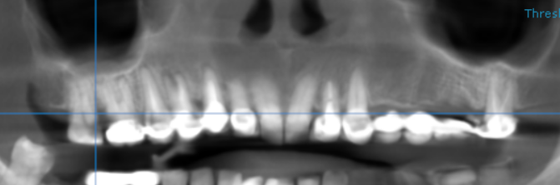

3-DIMENSIONAL VIEW

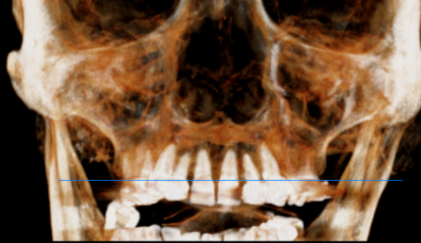

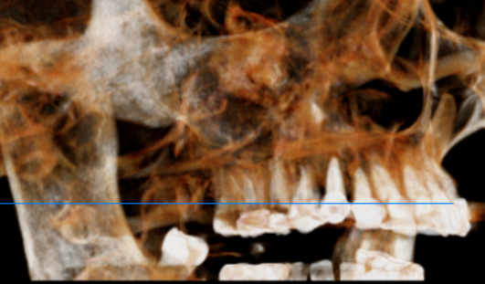
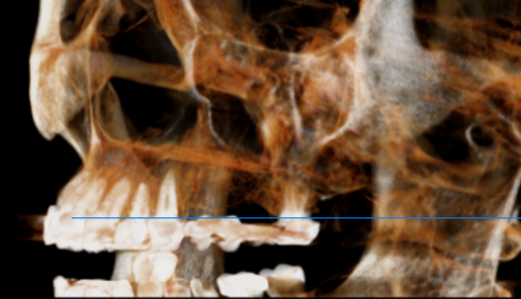

CROSS SECTIONAL VIEW

15 region | 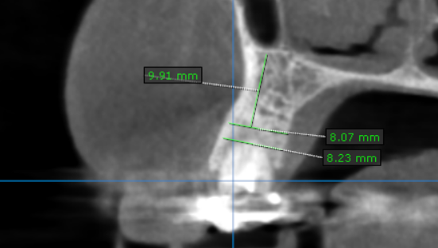
16 region | 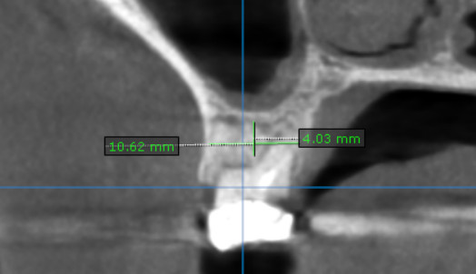
17 region | 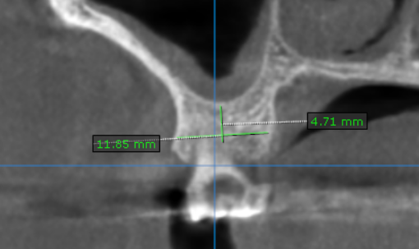
25 region | 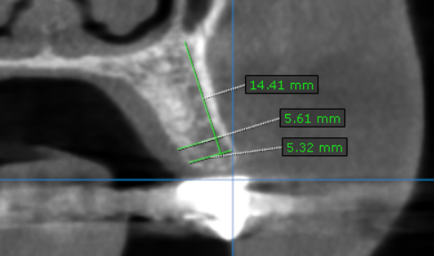
26 region | 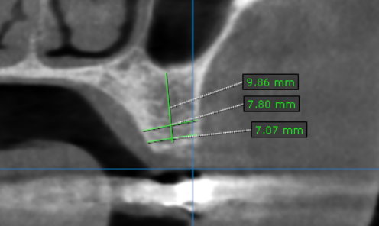
27 region | 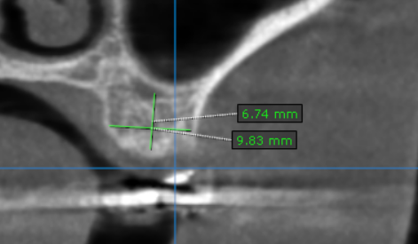

**** End of report ****

